**R Programming Assignment**

**1.Create a graph with two vectors and include 10 points each ?**

x< -seq

y< -seq(0,10,1.0)

plot(x,y)

l< -lm(y~x)

abline(l

Output:

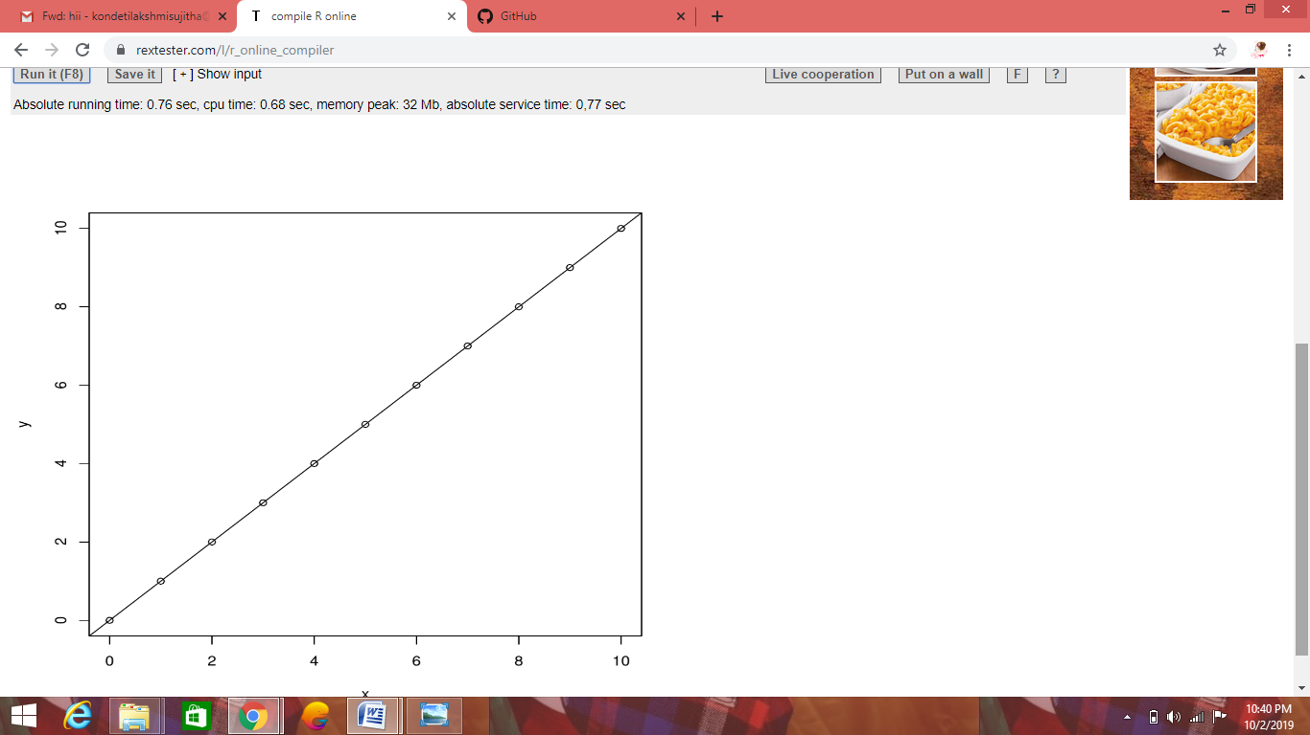

x< -seq(0,10,1.0)

y< -seq(0,10,1.0)

plot(x,y)

Lmout< - lm(y~x)

p

plot

**2.Exlain about the probability distribution and execute normal distribution in R?**

**Probability Distributions:**

A probability distribution describes how the values of a random variable is distributed

**Basic Probability Distribution:**

* The Normal Distribution
* The Poisson Distribution
* The Binomial Distribution
* The Exponential Distribution
* X2

**Normal Distribution:**

The normal distribution is represented in R by dnorm , pnorm and qnorm..

The probability density dnorm and cumulative distribution pnorm are defined on the entire real axis

**For example:**

z<-seq(-3.5,3.5,0.1)

q<-(0.001,0.999,0.001)

dStandarNormal <- data.frame(Z=z,

Density=dnorm(z, mean=0, sd=1),

Distribution=pnorm(z, mean=0, sd=1))

qStandarNormal <- data.frame(Q=q,

Quantile=qnorm(q, mean=0, sd=1))

Head(dStandardNormal)

**Output:**

**Z Density Distribution**

1 -3.5 0.0008726827 0.0002326291

2 -3.4 0.0012322192 0.0003369293

3 -3.3 0.0017225689 0.0004834241

4 -3.2 0.0023840882 0.0006871379

5 -3.1 0.0032668191 0.0009676032

6 -3.0 0.0044318484 0.0013498980

**Poisson Distribution :**

The poisson distribution is represented R by dpois,ppois, and qpois . The probability density dpois and cumulative distribution ppois are defined on non-negative integers**.**

**For example:**

lower < - qpois(0.001, lambda=2.5)

upper < - qpois(0.999, lambda=2,5)

n < - seq(lower, upper ,1)

q < - seq(0.001,0.999,0.001)

dPoisson25 < - data.frame(N=n,

Density=dpois(n, lambda=2.5),

Distribution=ppois(n, lambda=2.5))

qPoisson25 < - data.frame(Q=q, Quantile=qpois(q, lambdq=2.5))

head(dPoisson)

**Output:**

**N Density Distribution**

1 0 0.08208500 0.0820850

2 1 0.20521250 0.2872975

3 2 0.25651562 0.5438131

4 3 0.21376302 0.7575561

5 4 0.13360189 0.8911780

6 5 0.06680094 0.9579790

**Binomial Distribution:**

The Binomial distribution f(n,p) is represented R by dbinom,pbinom, and qbinom. The probability density dbinom and cumulative distribution are defined on the non-negative integers up to and including n.

**For example :**

lower < - qbinom(0.001, size=100, prob=0.5)

upper < - qbinom(0.999, size=100, prob=0.5)

n < - seq(lower, upper, 1)

dBinom100 < - data.frame(N=n,

Density=dbinom(n, size=100, prob=0.5),

Density=pbinom(n, size=100, prob=0.5))

qBinom100 < - data.frame(Q=q, Quantile==qbinom(q, size=100, prob=0.5))

head(dBinom100)

**Output:**

**N Density Distribution**

1 35 0.0008638557 0.001758821

2 36 0.0015597394 0.003318560

3 37 0.0044728800 0.006016488

4 38 0.0044728800 0.010489368

5 39 0.0071107323 0.017600100

6 40 0.0108438667 0.028443967

**Exponential Distribution:**

The Exponential Distribution f(r) is represented R by dexp,pexp, and qexp. The probability density dexp and cumulative distribution pexp are defined on the non-negative reals.

**For example:**

lower < - floor(qexp(0.001, rate=0.2))

upper < - ceiling(qexp(0.999, rate=0.2))

t < - seq(lower, upper ,0,1)

q < - seq(0.001,0.99,0.001)

dex02 < - data.frame(T=t,

Density=dexp(t, rate=0.2)

Distribution=pexp(t, rate=0.2))

qexp02 < - data.frame(Q=q, Quantile=qexp(q, rate=0.2))

head(dexp02)

**Output:**

**T Density Distribution**

1 0.0 0.2000000 0.00000000

2 0.1 0.1960397 0.01980133

3 0.2 0.1921579 0.03921056

4 0.3 0.1883529 0.05823547

5 0.4 0.1846233 0.07688365

6 0.5 0.1809675 0.09516258

**X2 Distribution :**

The x2(df) distribution is represented R by dchisq,pchisq and qchisq . df is the number of degree of freedom. The probability density dchisq and cumulative distribution pchisq are define on the non-negative reals.

**For example:**

lower < - floor(qchisq(0.001, df=10)

upper < - ceiling(qchisq(0.999,0.001)

dchisq10 < - data.frame(X=x,

Density=dchisq(x, df=10)

Distribution=(pchisq(x, df=10))

qchisq10 < - data.frame(Q=q, Quantile=qchisq(q, df=10))

head(dchisq10)

**Output:**

**X Density Distribution**

1 1.0 0.0007897535 0.0001721156

2 1.1 0.0010998857 0.0002660262

3 1.2 0.0014817914 0.0003944860

4 1.3 0.0019414257 0.0005649763

5 1.4 0.0024839611 0.0007855354

6 1.5 0.0031137444 0.0010646778

* **Creating a normally distributed.**

x< -seq(-20, 20, by=-1)

y< -dnorn((x, mean =5.0,sd=1.0)

ploat(x,y, main = “Normal Distribution”, col=”blue”)

Output:

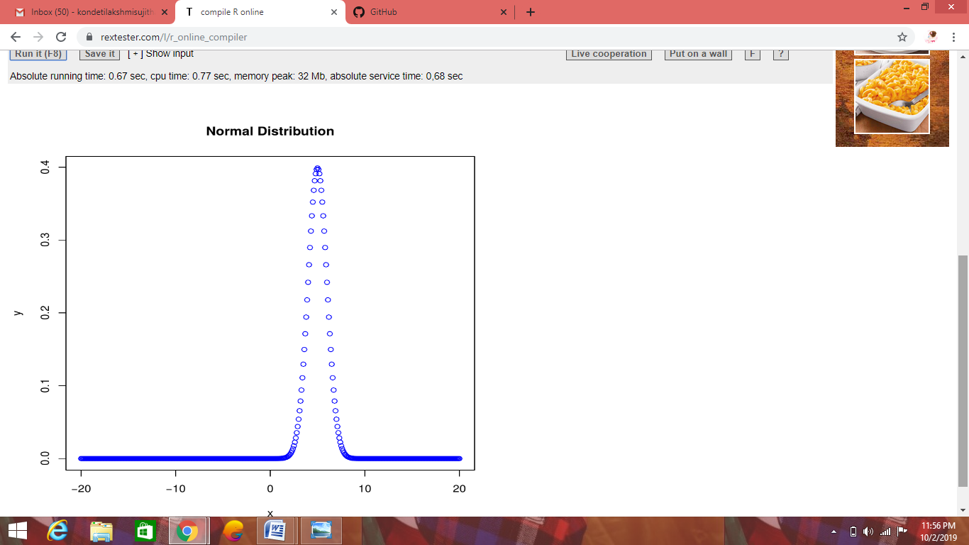

**3. Execute binomial distribution and create histogram with size 1 to 10. and prob(0.1 to**

**0.9) each with n value 10 ?**

**Binomial Distribution:**

The binomial distribution model deal with finding the probability of success of an event has only two possible outcomes in a series of experiments.

R has four in-built functions to generate binomial distribution. They are

dbinom(x, size, prob)

pbinom(x, size, prob)

qbinom(p, size, prob)

rbinom(n, size, prob)

**where as :**x is a vector of number

* p is a vector of probabilities
* n is number of observation
* size is the number of trials
* prob is the probability of success of each trial

**pbinom:**

x< - pbinom(25,50,0.5)

print(x)

output:

[1] 0.5561376

**qbinom:**

The function takes the probability value and gives a number whose cumulative valuematches the probability value.

Example:

x < - qbinom(0.25, 51,1/2)

print(x)

output:

[1] 23

**rbinom:**

The function generates required number of random values of given probability from a given sample.

Example:

x < - rbinom(8, 150, 4)

print(x)

Output:

[1] 58 61 59 66 55 60 61 67

**Histogram:**

**x < - c(1, 3, 4, 5, 6, 7, 8, 9, 2, 10)**

**hist(x, prob=0.9, n=10)**

**Output:**

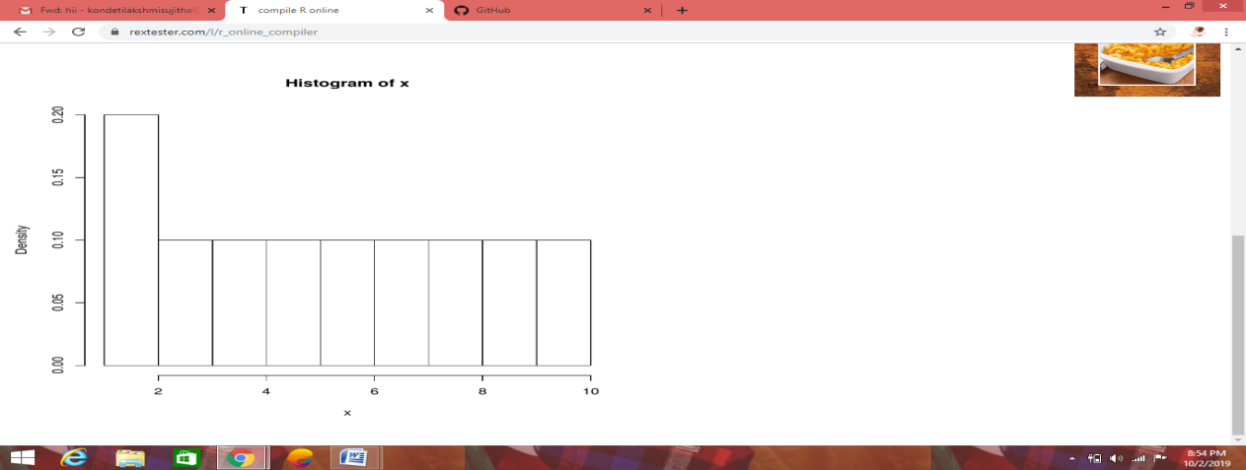

DONE BY:

K.LAKSHMI SUJITHA

18HP1A1215

IT